a..:::. =..-

kule *onlu*

mini tünel

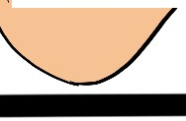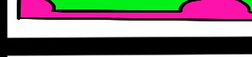*;3J* nakli e • - i i O a

0lku - konu

utmak :=

------

alim

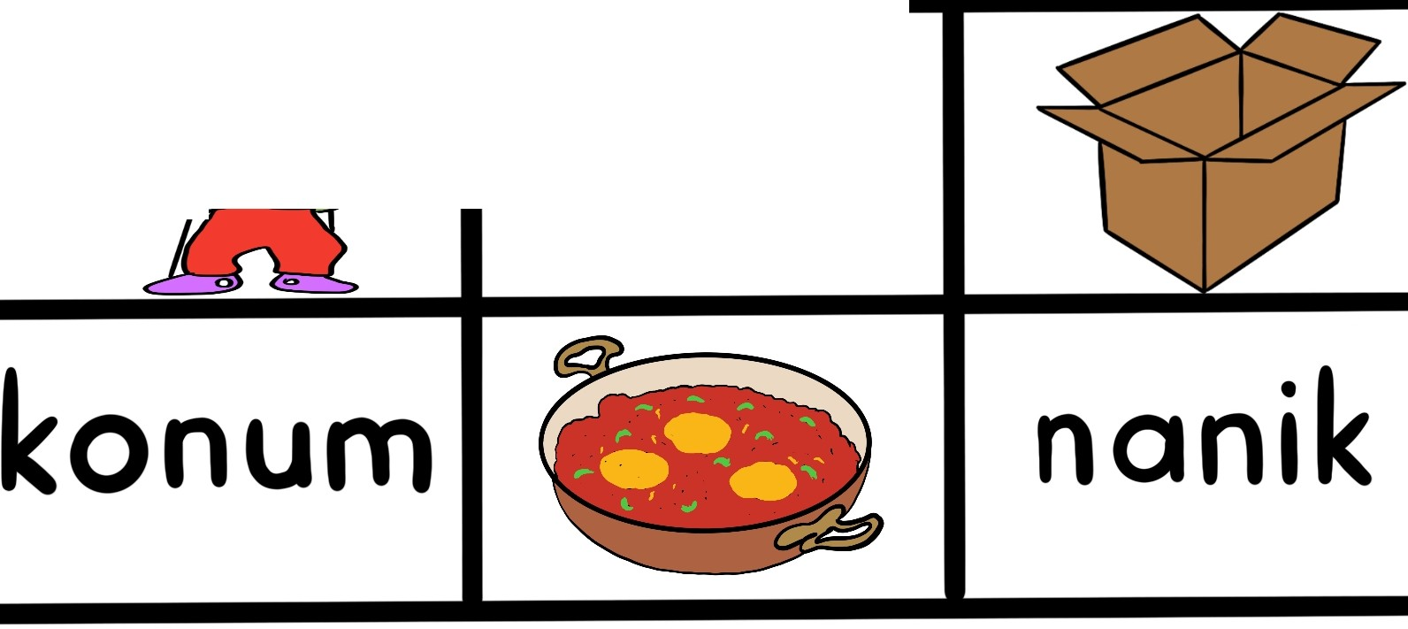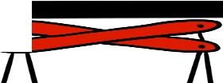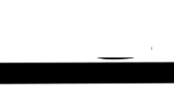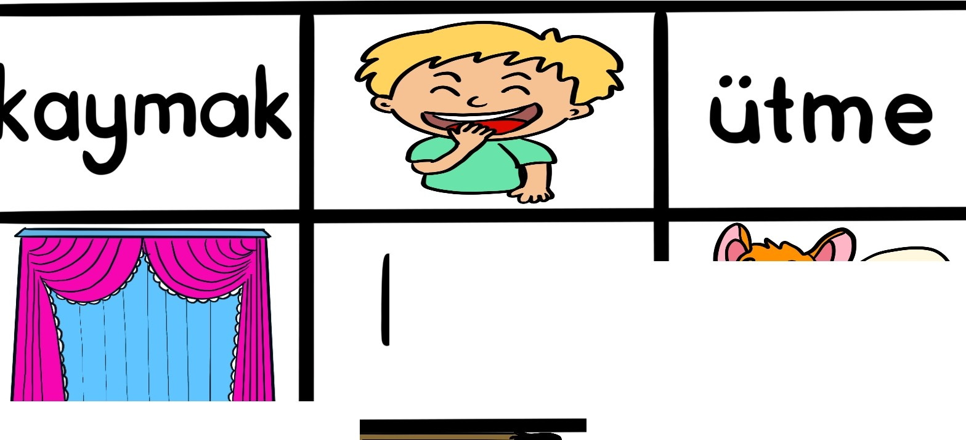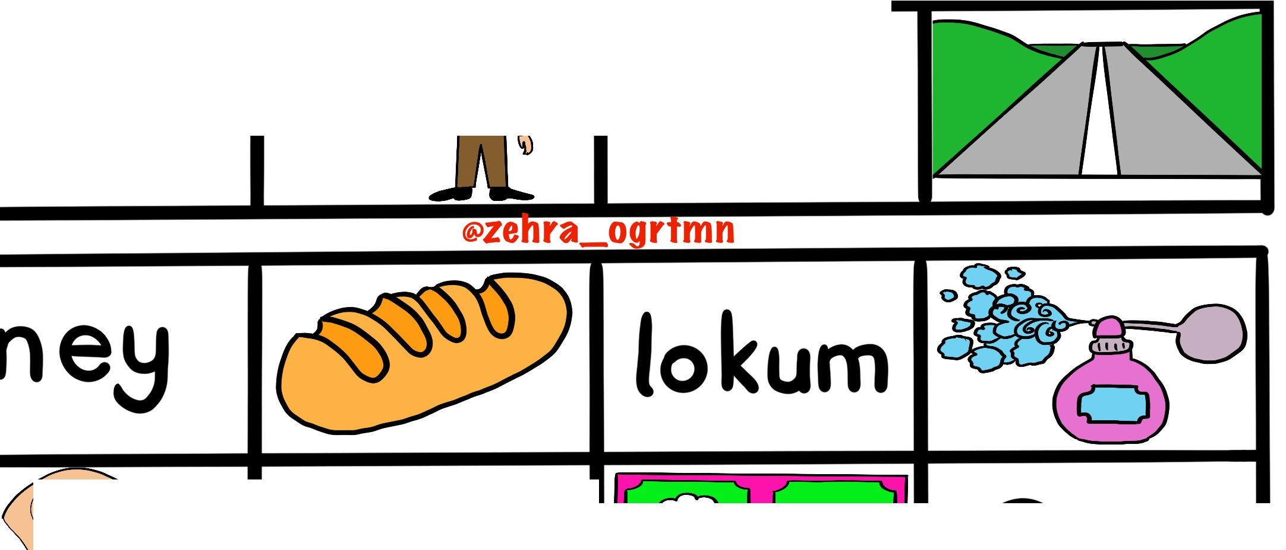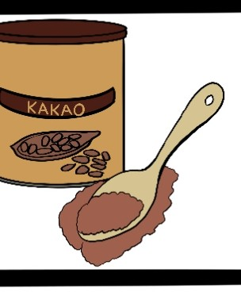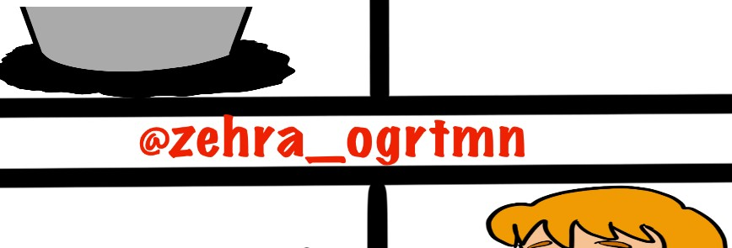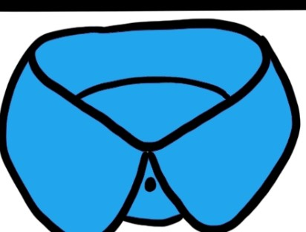

....... -----........ 111111111111!!!

Ummet *:* Emel

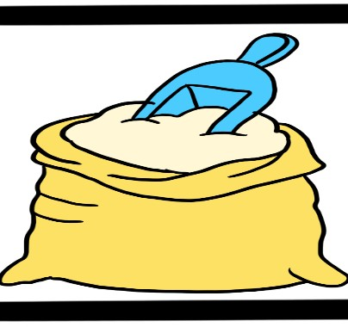

mU{k elek

etli _..._ -.-.'-,1

a et

UnlU · etkin

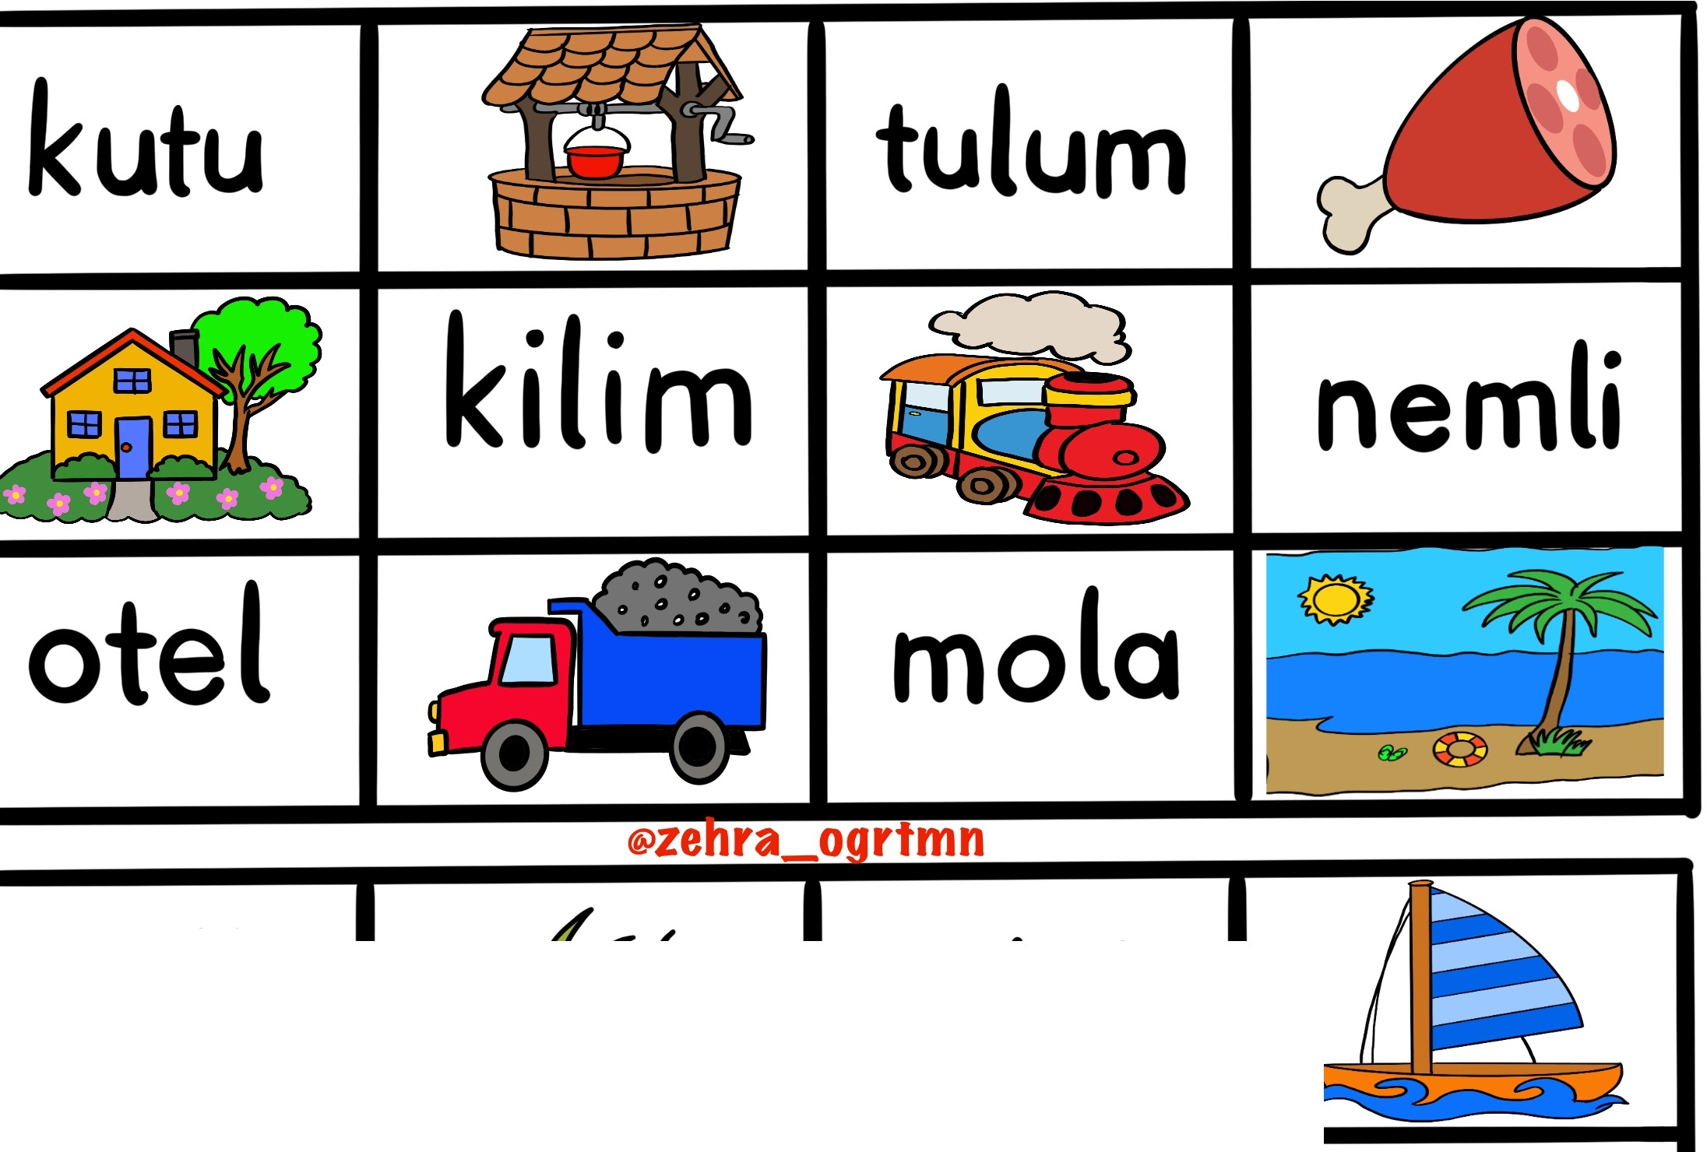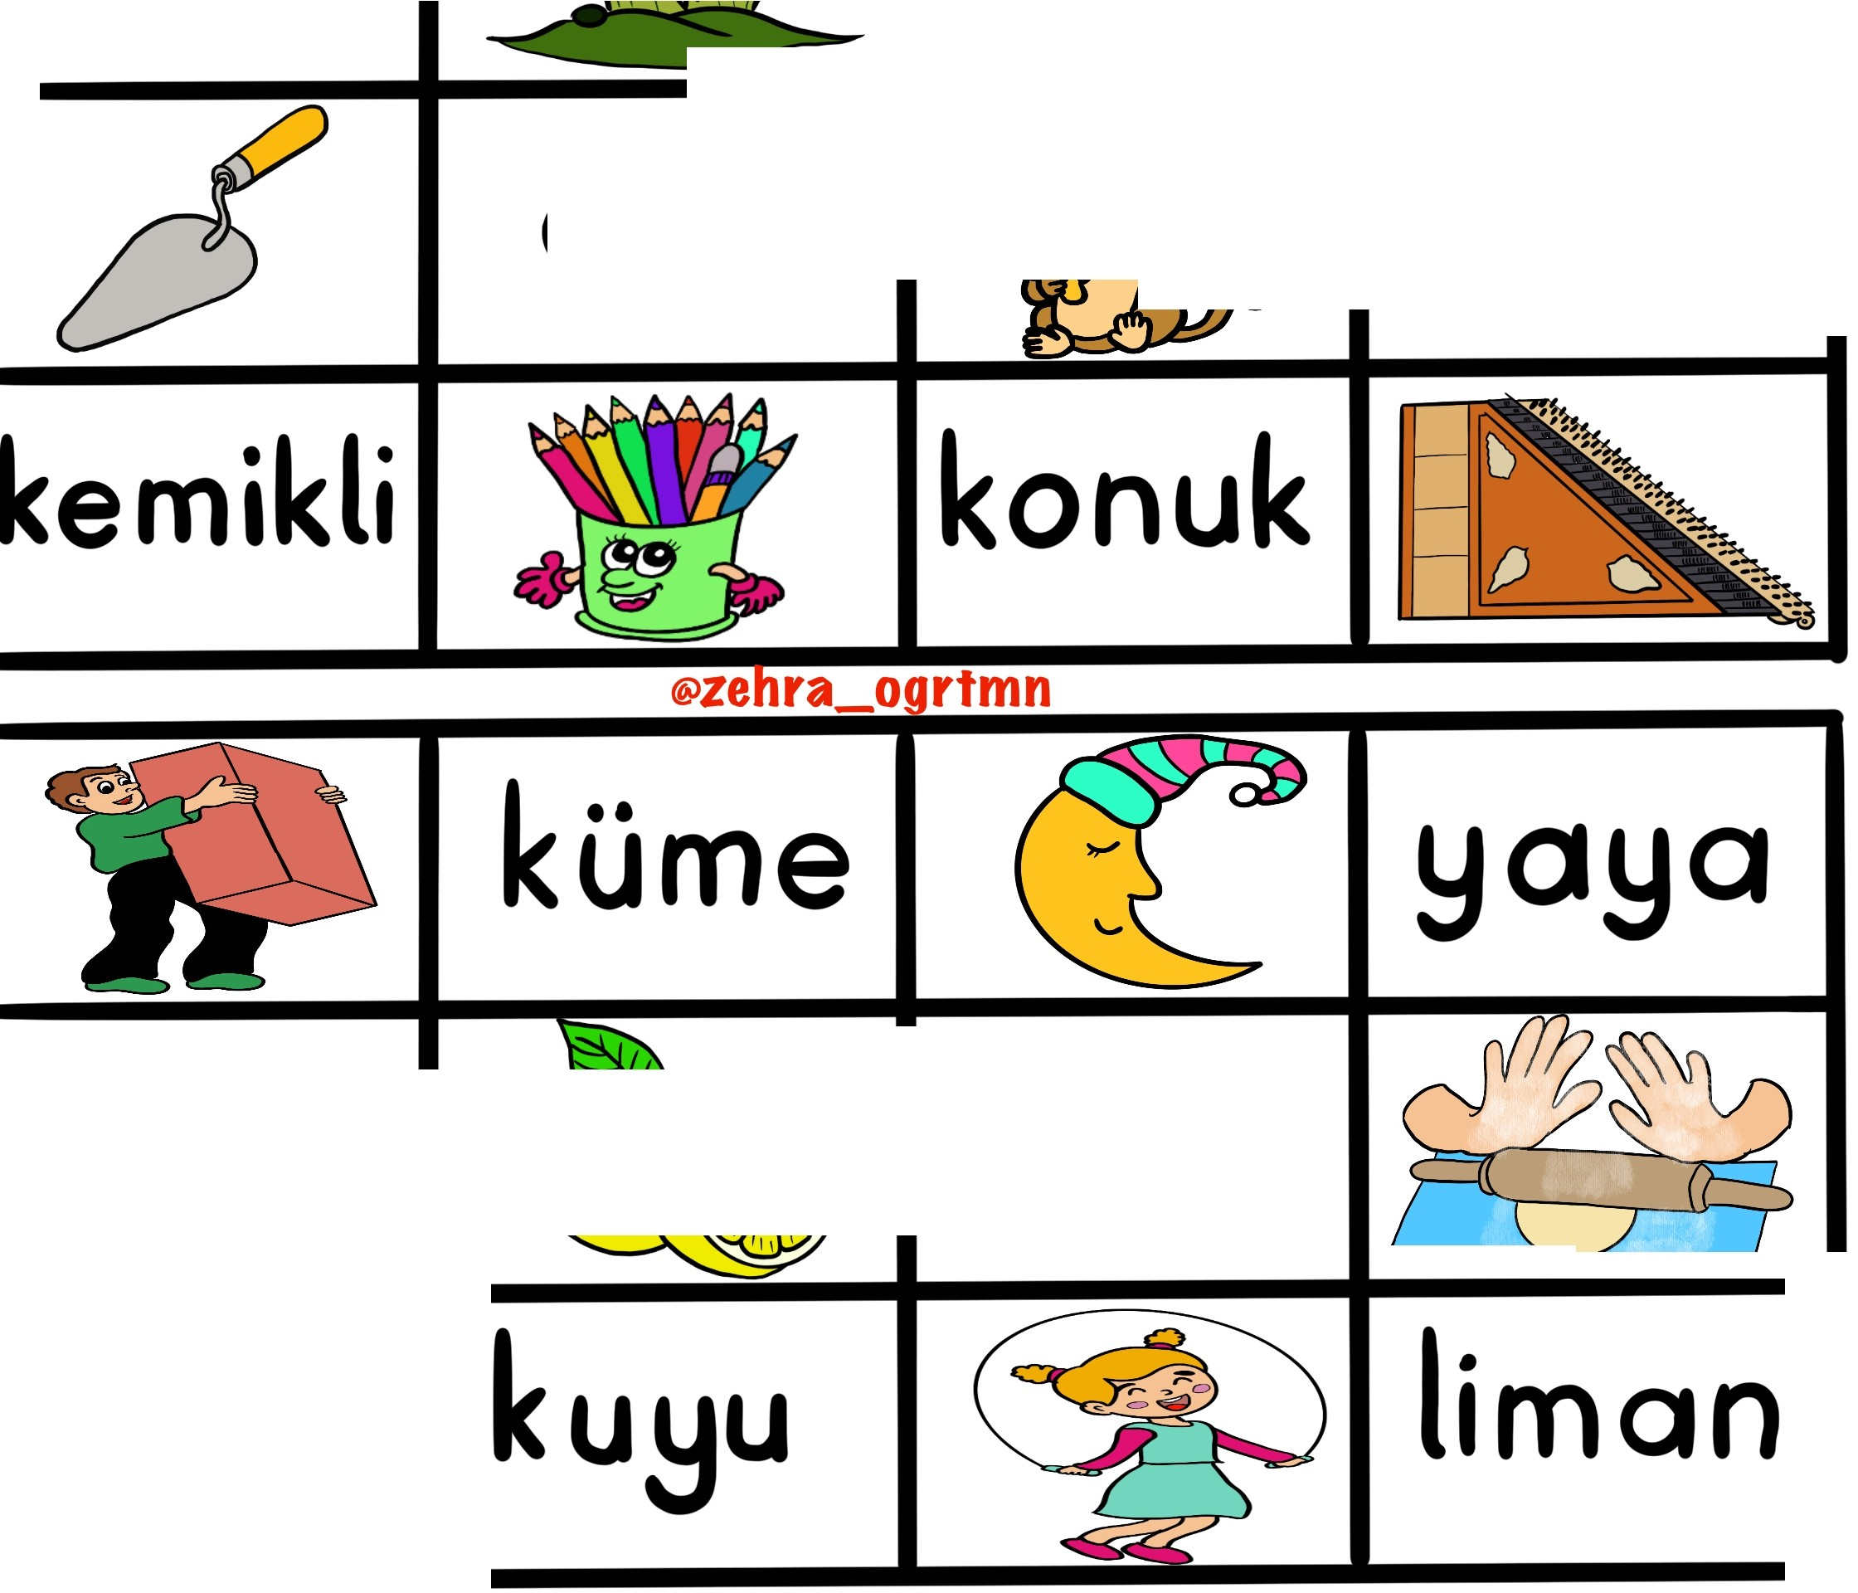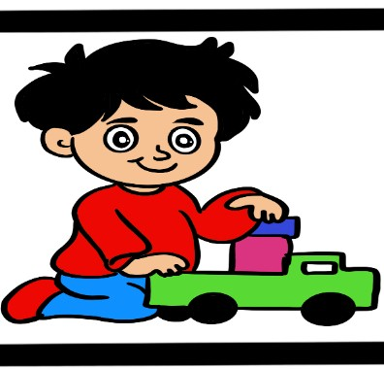

<---.......::::

@zenra_ogrtmn

|  |  |  |  |
| --- | --- | --- | --- |
| kutu | kuyu | tulum | et |
| konut | kilim | tUtmek | nemli |
| otel | kam on | mola | tatil |

|  |  |  |  |
| --- | --- | --- | --- |
| mU{k | ot | elek | !jelkenli |
| mala | etli | ma!lmun | a et |
| kemikli | kalemlik | konuk | kanun |

@zebra o irtmn

|  |  |  |  |
| --- | --- | --- | --- |
| Uk  UnlU | kUme  limon | O!:J  etkin | yaya  unlu |
| o un | ku u | atfa | liman |

@zebra oartmn

|  |  |  |  |
| --- | --- | --- | --- |
| ka mak | komik | Utme | kakao |
| tul | kule | tilki | *onlu* |
| m1• n1• | muatlim | tGnel | ol |

|  |  |  |  |
| --- | --- | --- | --- |
| ne | ekmek | lokum | koku |
| kulak | nakli e | menu•• | O a |
| ••  Ulku | kul | konu | omlet |

@zebra o irtmn

aka

Ummet

utmak Mine

kukla

Emel

un

konum menemen

alim

koli

nanik